Artwork using natural resources
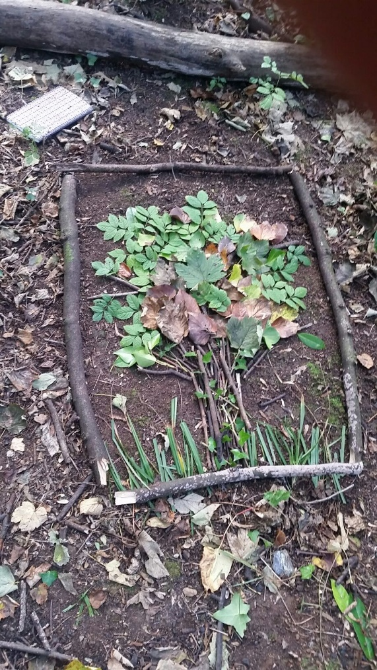

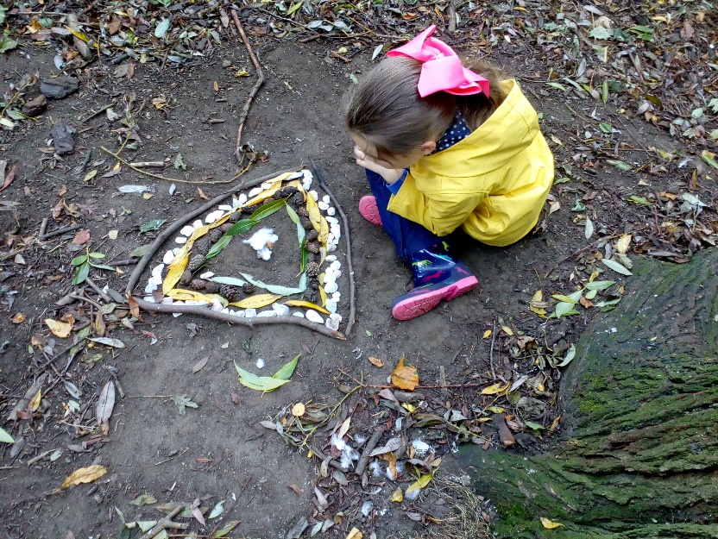

Dream Catchers
. This is a good activity to add in Maths – talking about shape, long and short etc.
Please see pictures below for some examples
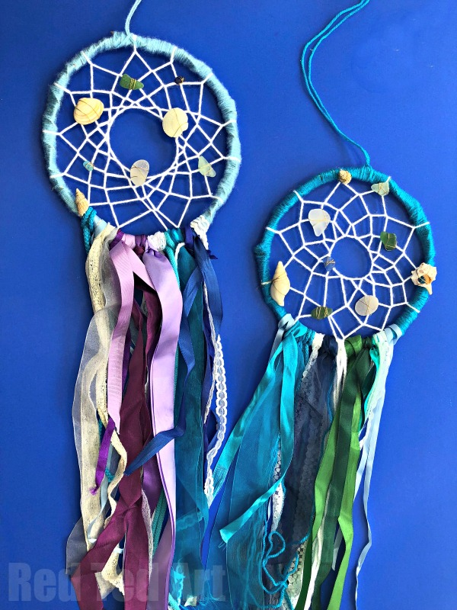
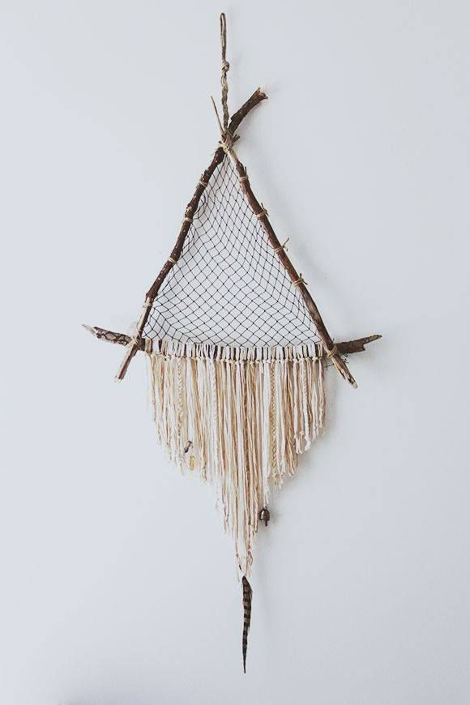
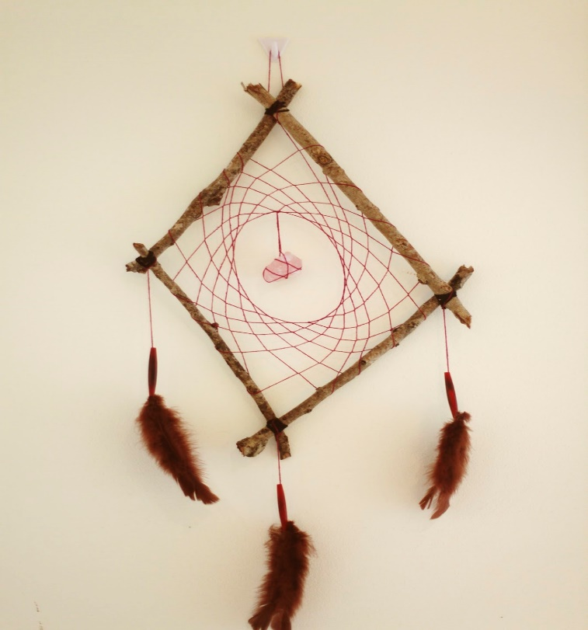
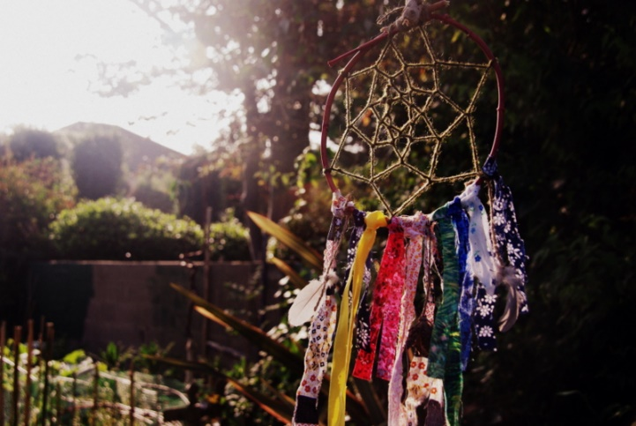

Tree Clay Faces
Take the children to trees on hill in sensory garden. Get pupils to go on a scavenger hunt to see what natural materials they can find.
Take about 500g of clay and demonstrate how you’d press it onto the tree. Pinch out some of the clay to make a nose and make eye holes with your thumbs. Add objects found during the scavenger hunt to make a friendly looking face, e.g. moss, berries and grass.
When they’ve finished, have a quick look at all the faces. Take photos of all of the faces completed.
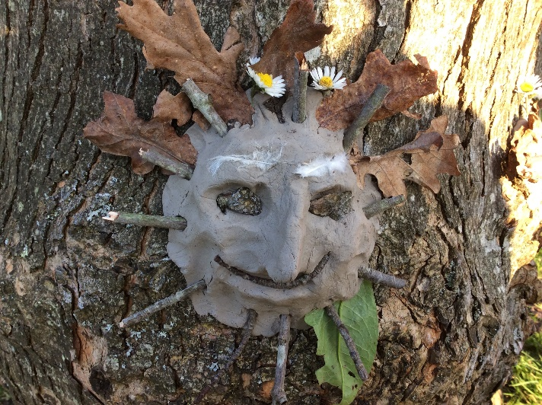
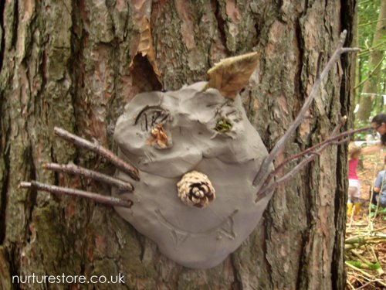

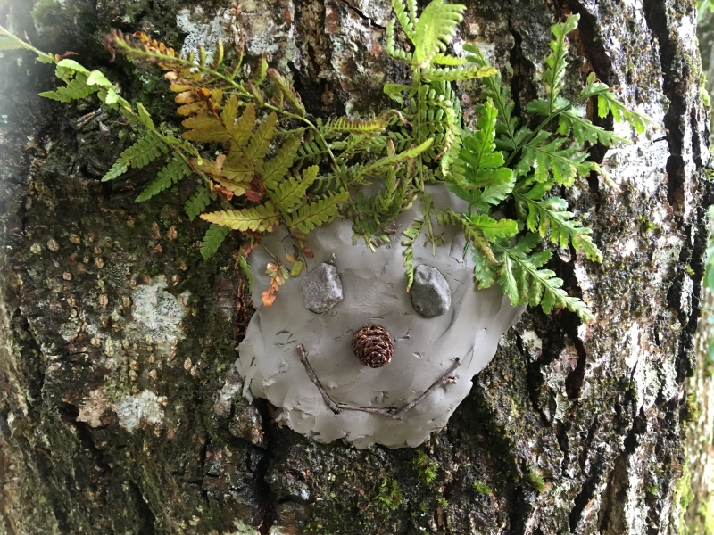

Bug Hotels
To make your bug hotels you will need following materials:
Old wooden pallets
Strips of wood
Moss
Dry Leaves
Pine Cones
Old logs
Bark
Pine Cones
Stones
Any other natural materials you can find
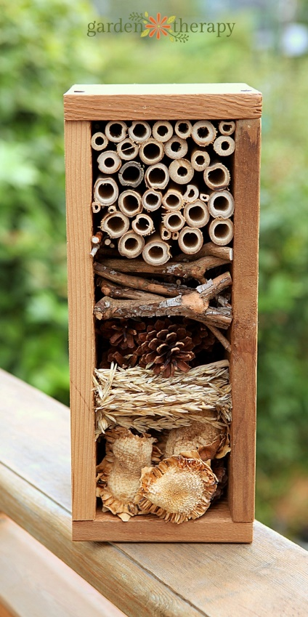
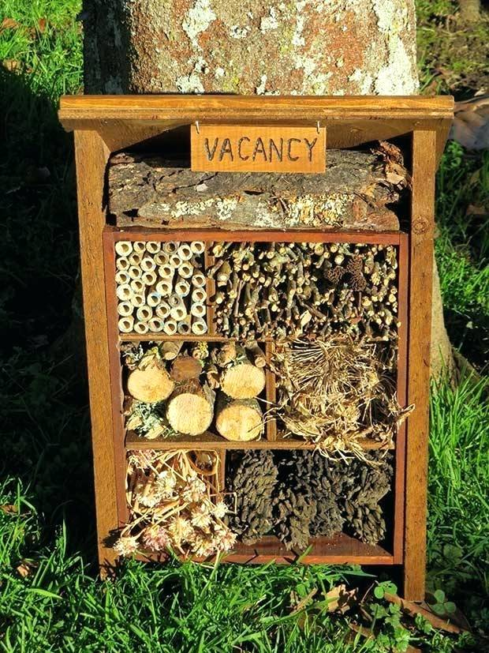

Wildflower or bird Seed Balls
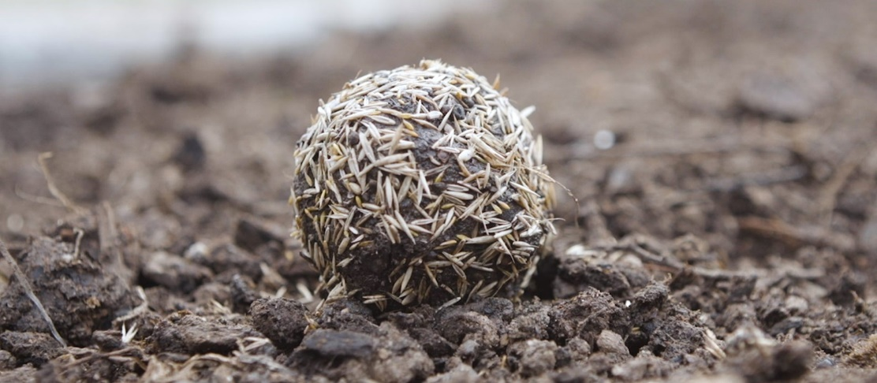

Instructions
- Mix 10 small cups of soil with one cup of flour.

- Slowly add water to the mixture until it turns like a sticky dough.

- Roll into a golf size ball

- Fill a tray with wildflower seeds and roll the ball in it until covered

- Leave to dry for up to 2 days and then they are ready to be thrown into the garden

Mini Beast Hunt
Choose an area outside to explore. Pupils look her logs, leaves, branches and see what mini-beasts they can find. Could extend this further by creating tally sheets and then pictograms using stones, leaves or sticks to represent number found. If you have access to magnifying glasses could use these to enhance views.
Micro Journey
Please see attached sheet.
Journey Sticks
Please see attached Journey Sticks sheet. Extend this activity by getting pupils to identify objects they have attached on to their journey stick, writing a short story on their journey around school or drawing a picture of their journey stick.
Also could create mobiles instead secure two sticks together and hand a range of objects from them for pupils in wheel chairs.
Memory Tree
Pupils share experiences of being outside for the day and attach them to the hedges and trees in the bottom corner of the field. Or if you notice pupils enjoying a specific activity or communicating with each other record and attach to the trees. I will put some tags in a box in my classroom come and grab some at the start of the day.
Tree Survey
Please see attached sheet on trees. Pupils go around school field and sensory garden looking at different leaves and identifying what they find.

There are lots more ideas for activities that you could deliver during the day a good resource is: https://outdoorclassroomday.org.uk/resources/lesson-ideas/

